**Design of Patrol Dining Shelter for the**

**Blair Atholl Jamborette**

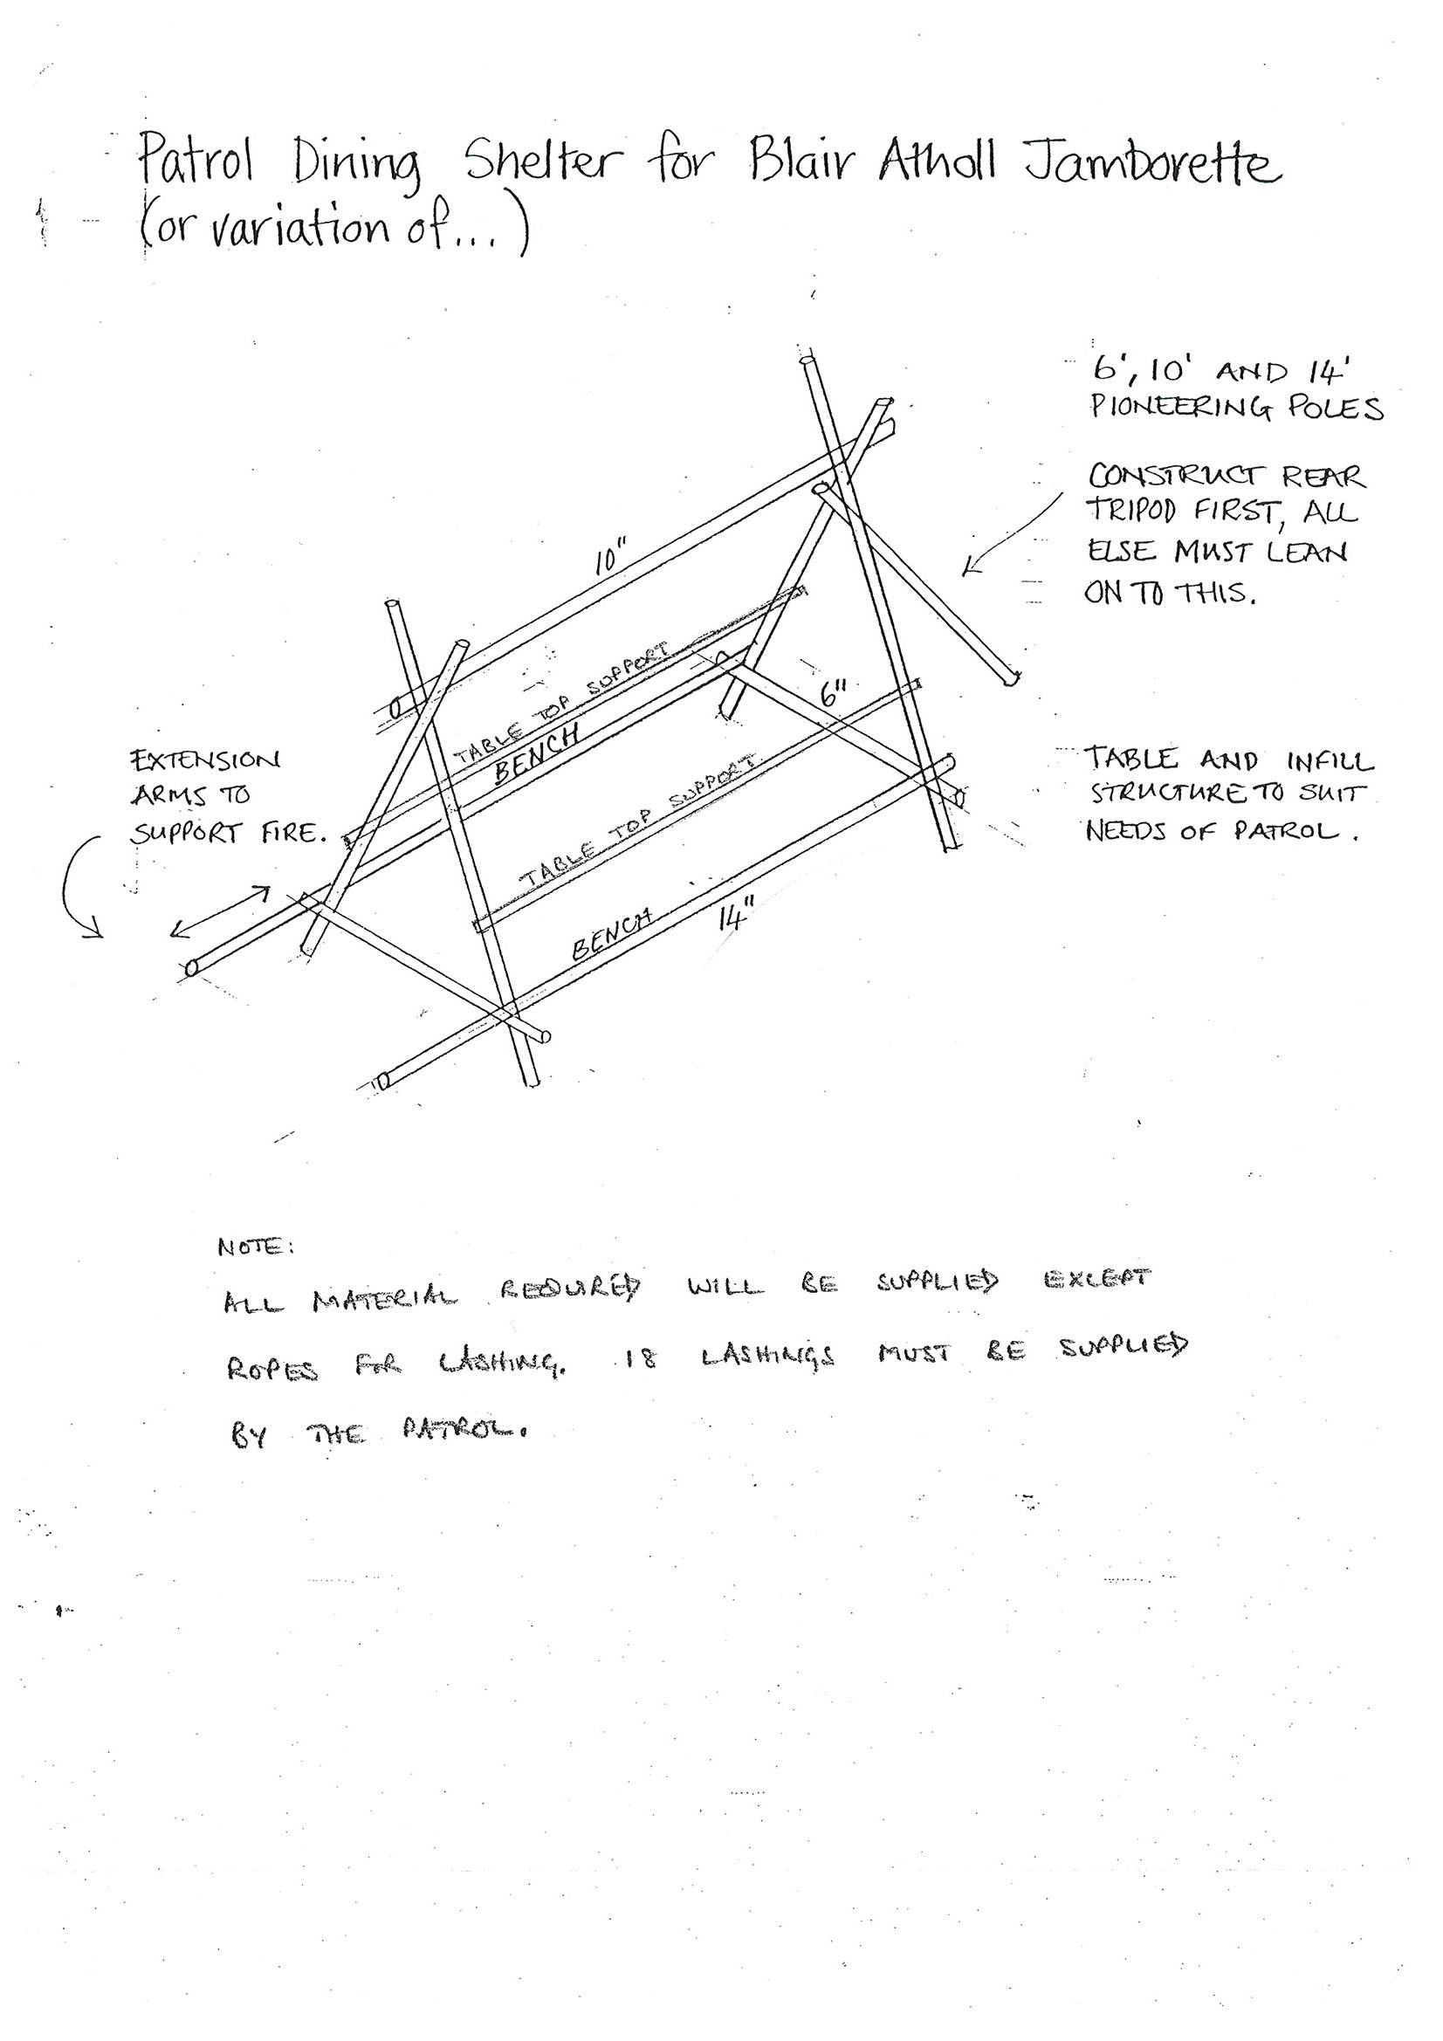

**Notes:**

All materials required are supplied by the camp except for the ropes needed for the lashings. **18 lashing lengths must be supplied by the patrol (natural fibre, not polypropylene).** At least 8mm rope is recommended. 16 ropes of 6m and 4 of 8m are recommended and testing with actual pioneering timber is advisable.

All pole sizes given are in feet.